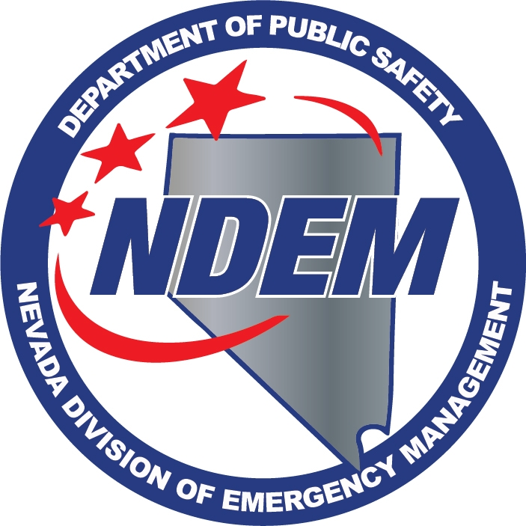 DEPT. OF PUBLIC SAFETY
DIVISION OF EMERGENCY MANAGEMENT
AB 239 REGULATION WORKSHOP
MINUTES

Attendance | Date | October 14, 2015
 | Time | 10:00 AM
 | Location | Legislative Building  401 S. Carson St., Room 3138  Carson City, NV 89701
 | Method | Record/Live Stream
 | Recorder | Chris Molnar
 | Present
Caleb Cage | X | Chief/Nevada Division of Emergency Management/Homeland Security Advisor
Samantha Ladich | X | Senior Deputy Attorney General

Call to Order – Caleb Cage

Caleb Cage, Chief of the Nevada Division of Emergency Management, called the workshop to order at 10:00am. He told the attendees the Department of Public Safety, Division of Emergency Management, is responsible for the regulations pursuant to Assembly Bill 239.

1. Public Comment

Chief Cage called for public comment, and there was no public comment.

2. Workshop - Overview

Chief Cage explained the purpose of the workshop was to solicit comments on regulations related to the operation of Unmanned Aerial Vehicles (UAV) by public agencies, pursuant to AB239. The division seeks input on specific public purposes that are appropriate and necessary for the operation of UAVs by public agencies.

Chief Cage gave a condensed version of AB 239. He said the bill is an act relating to aircraft. It regulates operators of unmanned aerial vehicles in the state and it revises the definition of aircraft to include UAVs. It prohibits the operation or use of an UAV under certain circumstances or for certain purposes. It authorizes a law enforcement agency to operate an UAV and requires the Dept. of Public Safety to establish a registry of UAVs and report on that registry to the Legislature on an annual basis.

He told the attendees that Section 18 of the bill, which prohibits a person from weaponizing a UAV or discharging a UAV weapon, establishes that a violation of this would be felony. He continued by pointing out Section 18.5 prohibits a person from operating a UAV within certain distances of critical facilities or an airport, except under certain circumstances, where the operator obtains consent from the owner of the critical facility, the airport authority or the FAA.

Chief Cage continued with Section 19, by explaining this section of the bill authorizes a person who is a real property owner, or lawfully occupies real property, to bring an action of trespassing to the operator of a UAV, when the vehicle is within a certain horizontal and vertical distance of the property, and under certain circumstances. He said certain exceptions exist.

Chief Cage told the attendees that Section 20 prohibits a law enforcement agency from operating a UAV for the purpose of collecting evidence, where a person has a reasonable expectation of privacy, without a warrant. He went on to explain it does authorize law enforcement to use UAVs for certain purposes. Those include: exigent circumstances with probable cause to believe a person has committed a crime, or is about to commit a crime; where there is consent in writing; for search and rescue operations when there is an imminent threat to life and safety; under Declaration of Emergency by the Governor, within the geographic area covered in the declaration. He said Section 20 also prohibits the use of any photograph, image or recording obtained in a manner inconsistent with the requirements of the section and is not admissible and cannot be used to establish reasonable suspicion or probable cause.

Chief Cage continued to Section 21, which addresses public agencies. It authorizes public agencies to use a UAV if it is registered with the Department of Public Safety and if it is operated in accordance with the regulations adopted by the department. It prohibits a public agency from using a UAV if it is operated to assist law enforcement or to conduct criminal prosecution. It also prohibits photographs, images, recordings that were obtained in violation of this section. He explained that if it is obtained in violation of this section, it will be inadmissible in judicial, administrative, or other adjudicatory proceedings and cannot be used to establish reasonable suspicion.

Chief Cage moved on to Section 22, which requires the Department of Public Safety (department), to the extent money is available, to establish and maintain a registry for UAVs that are operated by public agencies. The registry will be developed on behalf of the Director of the Department Public Safety, by the Division of Emergency Management, and be maintained by the division. The section prescribes the department will provide an annual report to the Legislative Counsel Bureau outlining the activities of public agencies, related to the operation of UAVs. It also requires the department adopt regulations prescribing the purposes for which a public agency may use a UAV that is registered with the department, including, but not limited to: Fire Services, Emergency Medical Services, Protection of Critical Facilities that are public property and Search and Rescue Operations.

Chief Cage said Section 23 contains definitions mentioned in the bill. Those include the definition of critical facilities, department, law enforcement agency, public agency and unmanned aerial vehicle.

Chief Cage continued with Section 24.4 which revises provisions related to liability, to include UAVs, where the UAV is being operated over heavily populated areas or in public gatherings.

Chief Cage concluded his overview of AB 239, by explaining Section 24.8, which deals with intoxication. This section prohibits a person from operating a UAV while intoxicated or in a careless or reckless manner that would endanger the life of property of another. It establishes a violation would be a gross misdemeanor.

Lt. Eric Spratley, Washoe Co. Sheriff’s Office, said he worked with the legislators on AB 239, during the last session, and it works for the Sheriff’s Office, but he wanted to comment on Section 21.1(b) “Must not operate an unmanned aerial vehicle for the purposes of assisting a law enforcement agency with law enforcement or conducting a criminal prosecution.” He asked that when the regulations are being crafted, take into account the intent of the public agency, and what they may capture on video from a UAV while they are performing their duties, and not regulate as such that they cannot use that video. He said if a crime was captured unintentionally, on a UAV being used by a road crew, as an example, he wouldn’t want that video to stifle an investigation, or not able to be used in an evidentiary manner. He would want it turned over to law enforcement, or fire, or whomever, that they might have evidence of some type of crime, and be able to use it appropriately.

Steve Merrill, Chief Location Engineer with the Department of Transportation, commented on Section 22.4 “the department shall adopt regulations prescribing the public purposes for which a public agency may operate an unmanned aerial vehicle that is registered with the department pursuant to this section, including, without limitations: (a) the provision of fire services, (b) the provision of emergency medical services, (c) the protection of a critical facility that is public property (d) search and rescue operations conducted for persons and property in distress.” He would like to see surveys, mapping purposes and inspections added to the list.

Daryl Cleveland, Truckee Meadows Community College, asked if Section 22 could be expanded to include education institutions for the purposes of training the public safety members in the use of UAVs as a function of the Nevada institution. Chief Cage added that the research universities in the state have UAV and UAS programs with the University of Nevada, Reno and the University of Nevada, Las Vegas. Mr. Cleveland commented he had just attended a Homeland Security Higher Education Summit, and one of the presenters was a member of the federal government, who clearly delineated the difference between UAV/UAS and drones. He said he did not see that specified in the bill. He said drones are designed as a flying mechanism that goes out with an intent and does not come back, whereas UAV/UAS are unmanned with a human interacter controlling the aircraft. He questioned if it should be defined between a drone and a UAV/UAS.

Mark Regan, North Lake Tahoe Fire Protection District, continuing on the subject of the mapping, suggested taking into consideration fuel management practices, defensive space, mapping and the “halo effect”, a fuels management practice of thinning fuels around neighborhoods.

Brent Harper, no affiliation, but has extensive background in fire service and he is a private pilot. He said he wanted to voice some concerns regarding the bill. He felt that 5 miles from an airport was too restrictive for the use of UAVs. He pointed out federal regulations has it 2 miles from an airport. He said to use the step down approach where the closer you get to the airport the lower you have to be, so the same thing should apply for UAVs. He also discussed registering the UAVs with agencies. His concern is when incident management teams come in to fight fires, and they come in with drones and drone operatives that are not registered with the state. He also questioned if an agency has to register their drones, and it is just a demonstration, and they don’t own it yet, but they are flying it in relationship to that agency. He said he just wanted his questions and comments on the record.

Tom Knight, Nevada Division of Forestry, said his division wants to be assured that UAVs don’t interfere with firefighter operations. He also said the division wants to be able to use UAVs for pre-fire and post-incident use, and resource and fuels management.

Chief Cage told attendees the law currently allows public agencies to use UAVs for fire service. He asked if that was general enough to also include using UAVs for resource and fuels management. He asked if anybody had an opinion on that. Tom Knight thought it was clear and stated again he just wanted to make sure it covered mapping and resource and fuels management. He felt leaving it general was a good idea.

John Dunn, Drone America, told the attendees another application for UAVs for fire use is communications relay. He also pointed out it can be used for spotting during a fire.

Daryl Cleveland, TMCC, pointed out in Section 22 that there was no mention of emergency management. He said there is no pre and post event for emergency management.

Chief Cage closed the workshop.

3. Public Comment
Chief Cage called for public comment, and there was no public comment. He adjourned the workshop.

